ERD Model PART 3
Illustrate that you understand normalization and how to use it to reduce uncontrolled redundancy in your database design by creating two ERD diagrams:

Answer: The normalization belongs with the customer details, order details, order status, payment and review. There are two sections in the normalization. One is customer details, order details and order status and another is payment and review.
Create the first using UML and the Umlet free utility.
Answer:
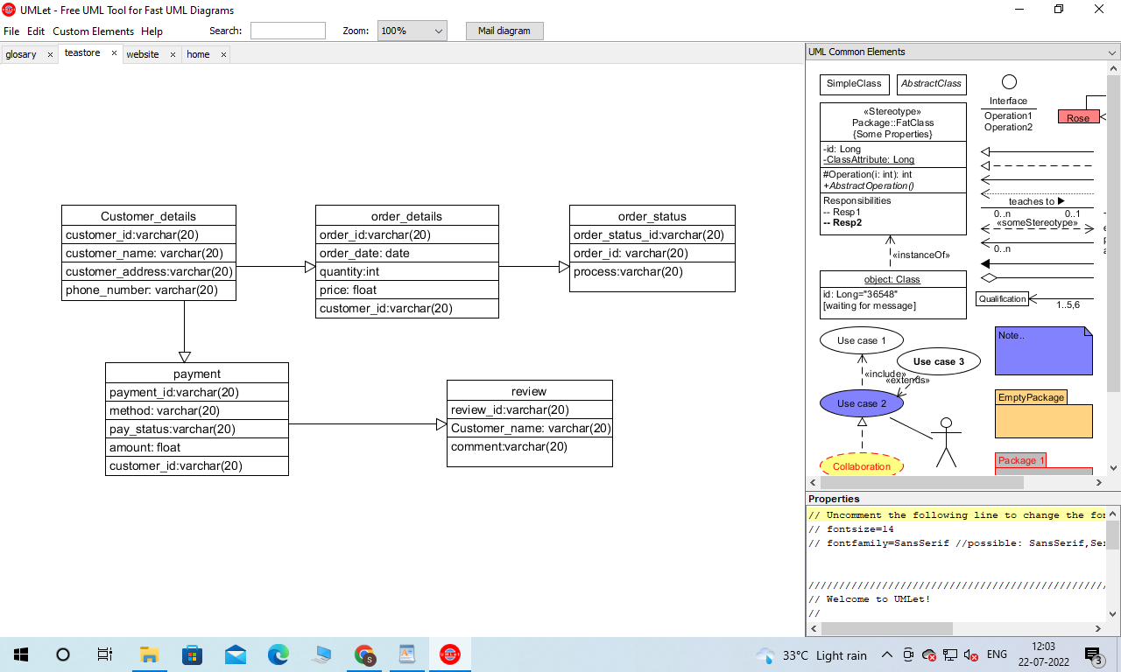

Create the second using Crow’s Foot notation in Vertabelo.
Answer:

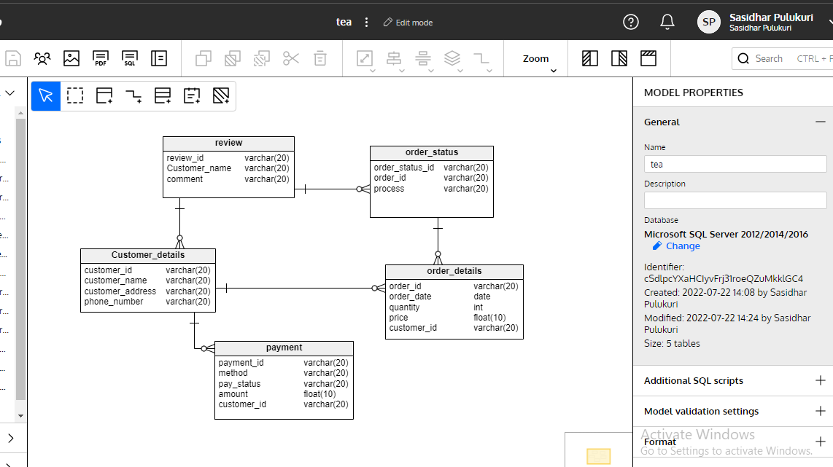
Changes:
Relationship Description:
Above diagram we create five entities for business purposes. To access the database with the data model we can simply know about the data and this is how we can create entity relationships here. Entities are related to each other. In the next part we describe the entity relationship which are as follows:
In the relationship diagram we create five entities:
review, order_status, Customer_details, order_details, payment. In the review entity has a one to many relationship between the Customer_details entity and order_status entity. In the order_status entity has one to many relationship with order_details Entity. Customer_details table relationship with payment table which has one to many. Customer_details Entity has also a one to many relationship with order_details Entity.
Entity Relationship always helps to know about the entity attribute, and the data of the attribute. So for the business purpose we create entity relationships with the different entity.

